SPRINT - 1

# Working With The Dataset (Loading The Dataset)

|  |  |
| --- | --- |
| Date | 18 November 2022 |
| Team ID | PNT2022TMID20305 |
| Project Name | Estimate The Crop Yield Using Data Analytics |

* View and analyze the data .
* First upload the data in IBM cognos after understanding Them. Cognos most supportive tool for this task, it can connect wide varitery of data, stored in variety of places .
* The might be stored in system storage , drive as txt file, csv file and other files , or in big data , relational or cube database on server in enterprise

# Login Into Ibm Cognos

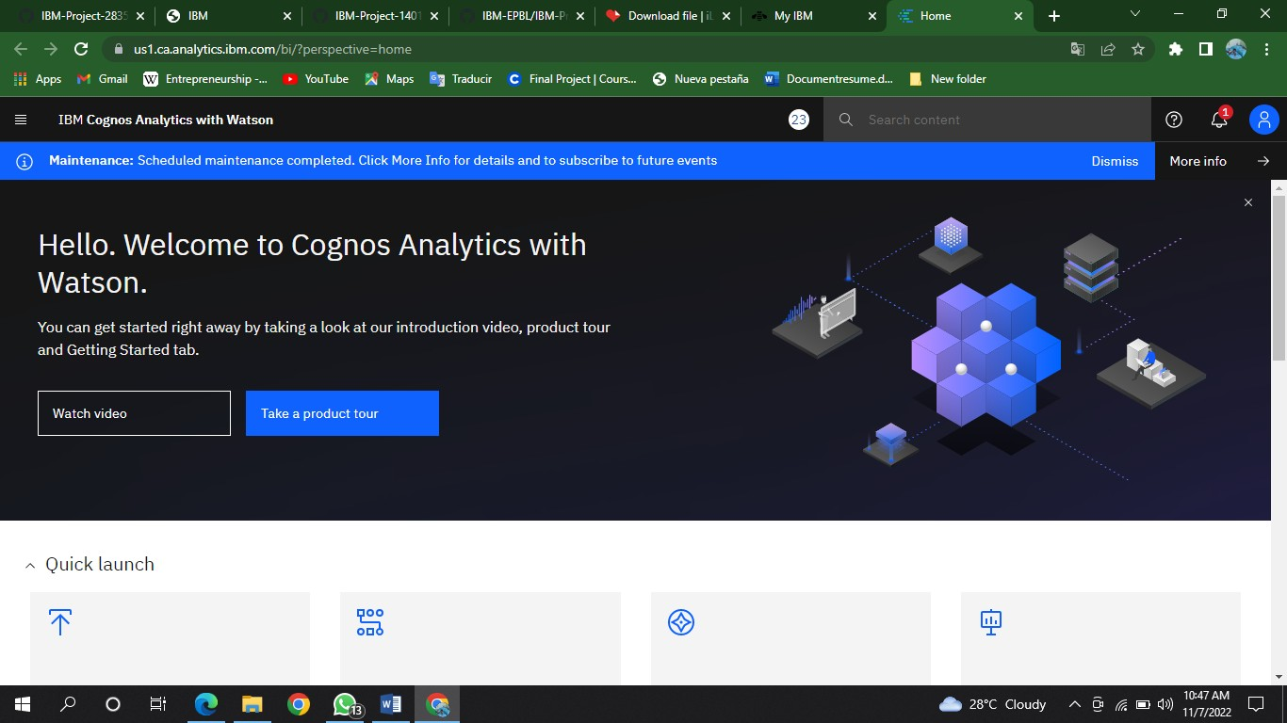

1. **Go To Menu,Click On Upload Data:**

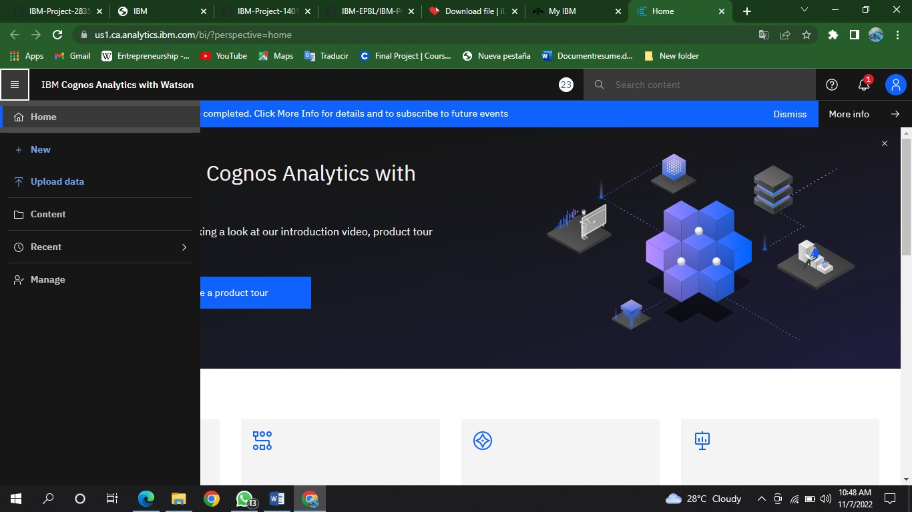

1. 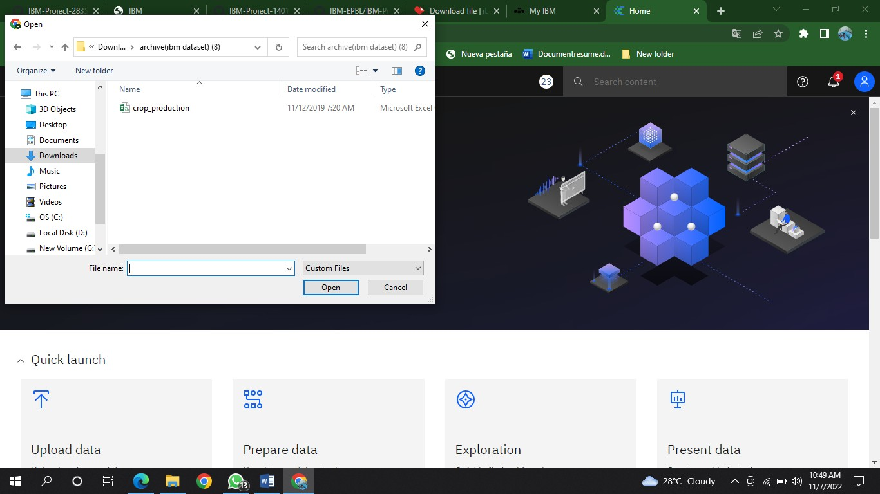**Select The Needed Dataset:**
2. **Click On Open And Wait Till The Dataset Is Uploaded:**

